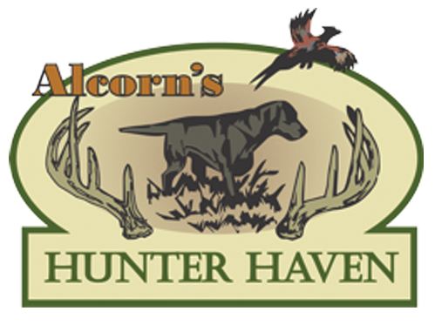

4399 460th Road Hay Springs, NE 69347 | ross@nebraskahuntingguide.com | (308) 430-0729

Merriam Turkey Hunting Packages

(Spring Turkey: March 25th - May 31st, Fall Turkey: Sept. 15- Jan. 31)

Fees

3-Day Hunt: $1800.00 plus 5.5% sales tax.
Deposit: $600 plus $33 tax due to hold your reservation at the time you book your hunt.

Extra Birds

You may try for additional Merriam turkeys with another license purchased from NE Game and Parks for Alcorn Hunter Haven fee of $500 per extra bird. Three birds are the limit that can be taken in a season.

Licensing Fees:

Licensing fees are $97 license per bird, $20 habitat stamp. Season limit is 3 tags per hunter. These are available on the Nebraska Game and Parks website at http://outdoornebraska.gov/

Basic Combination Hunts:

Upland game bird hunting can be combined with Merriam turkey hunts for additional $500 per day.

Standard Combo:

Seasonal deer hunting can be combined with Merriam turkey hunts for an additional $2,750 -
$5,000 per day depending on if it is an archery, black powder, or rifle hunt.
Seasonal antelope hunting can be combined with Merriam turkey hunts for an additional
$2,750.

Premium Combo:

Deer (seasonal), antelope (seasonal), upland game bird, and predator hunts can be combined with Merriam turkey hunts starting at an additional fee.

Combination hunts are a great option for the exceptional hunters that hit their targeted mark early and have time to spare in their booked hunts. It is also an ideal choice to optimize the challenge for the more extreme hunters that come to see and conquer.

Packages Include:

All of our hunts include an experienced hunting guide, Alcorn Kennel pointing Labs (for bird hunts), comfortable lodging at our remodeled 1930's barn, home-cooked meals, plus transportation to and from the field.

